**Phonebook Class**

* Attributes:
  + contacts : A list of contacts.

Methods:

1. Phonebook Constructor
   * Initialize contacts as an empty list.
2. insertContact(name, phone)
   * Create a new contact with the given name and phone.
   * Add the new contact to the list contacts.
   * Show a message: "Contact [name] added."
3. searchContact(name)
   * For each contact in contacts:
     + If the contact’s name matches the given name (case-insensitive):
       - Return the contact.
   * If no contact is found, return null.
4. deleteContact(name)
   * Initialize toRemove as null.
   * For each contact in contacts:
     + If the contact’s name matches the given name (case-insensitive):
       - Assign the contact to toRemove.
       - Break out of the loop.
   * If toRemove is not null, remove the contact from contacts.
     + Show a message: "Contact [name] deleted."
   * Otherwise, show a message: "Contact [name] not found."
5. updateContact(name, newName, newPhone)
   * For each contact in contacts:
     + If the contact’s name matches the given name (case-insensitive):
       - If newName is not empty or null, update the contact's name.
       - If newPhone is not empty or null, update the contact's phone number.
       - Show a message: "Contact [name] updated."
       - Exit the method.
   * If no matching contact is found, show a message: "Contact [name] not found."
6. getContacts()
   * Return the list of contacts.
7. sortContacts()
   * Sort contacts alphabetically by the contact name.
   * Show a message: "Contacts sorted."
8. analyzeSearchEfficiency()
   * Return the string: "The search operation is O(n), where n is the number of contacts."

The Contact class is a simple data structure to hold the contact's name and phone number. Here's the breakdown in pseudocode:

**Contact Class**

* **Attributes:**
  + name: The contact's name.
  + phone: The contact's phone number.

**Methods:**

1. **Contact Constructor (name, phone)**
   * Set the name attribute to the given name.
   * Set the phone attribute to the given phone.
2. **toString()**
   * Return a string in the format: [name]: [phone].

**PhonebookApp Class (extends JFrame)**

* **Attributes:**
  + phonebook: Instance of Phonebook class to store contacts.
  + displayArea: A text area to display the list of contacts.

**Constructor: PhonebookApp()**

1. Initialize the phonebook object.
2. Set up the application window:
   * Title: "Phonebook Application"
   * Size: 400x400 pixels
   * Default close operation: EXIT_ON_CLOSE
   * Layout: BorderLayout
3. **Set the background color of the app to aqua.**
4. **Title Panel:**
   * Create a title panel with the text "Namibian Phonebook" centered.
   * Set background color and font styling.
   * Add the title panel to the top of the window.
5. **Display Area:**
   * Create a non-editable text area to display contacts.
   * Set font and background styling.
   * Add a scroll pane to the center of the window containing the text area.
6. **Button Panel:**
   * Create a grid layout for the buttons (two columns, dynamic rows).
   * Add space around the panel using padding.

**Buttons and Actions:**

* **Insert Contact:**
  + Show dialogs to input contact name and phone number.
  + Insert the contact into the phonebook.
* **Search Contact:**
  + Show a dialog to input the name to search.
  + Display the contact if found, or show "Contact not found."
* **Display All Contacts:**
  + Clear the display area.
  + Retrieve all contacts from the phonebook.
  + If the phonebook is empty, display "Phonebook is empty."
  + Otherwise, display each contact.
* **Delete Contact:**
  + Show a dialog to input the name of the contact to delete.
  + Remove the contact from the phonebook.
* **Update Contact:**
  + Show dialogs to input the name of the contact to update.
  + Optionally enter a new name or phone number (leave empty to keep unchanged).
* **Sort Contacts:**
  + Sort the contacts alphabetically by name.
* **Analyze Efficiency:**
  + Display the search efficiency analysis (O(n)).

**Main Method**

* Use SwingUtilities.invokeLater to ensure the app's GUI is created on the Event Dispatch Thread (EDT).
* Create an instance of PhonebookApp and make it visible.

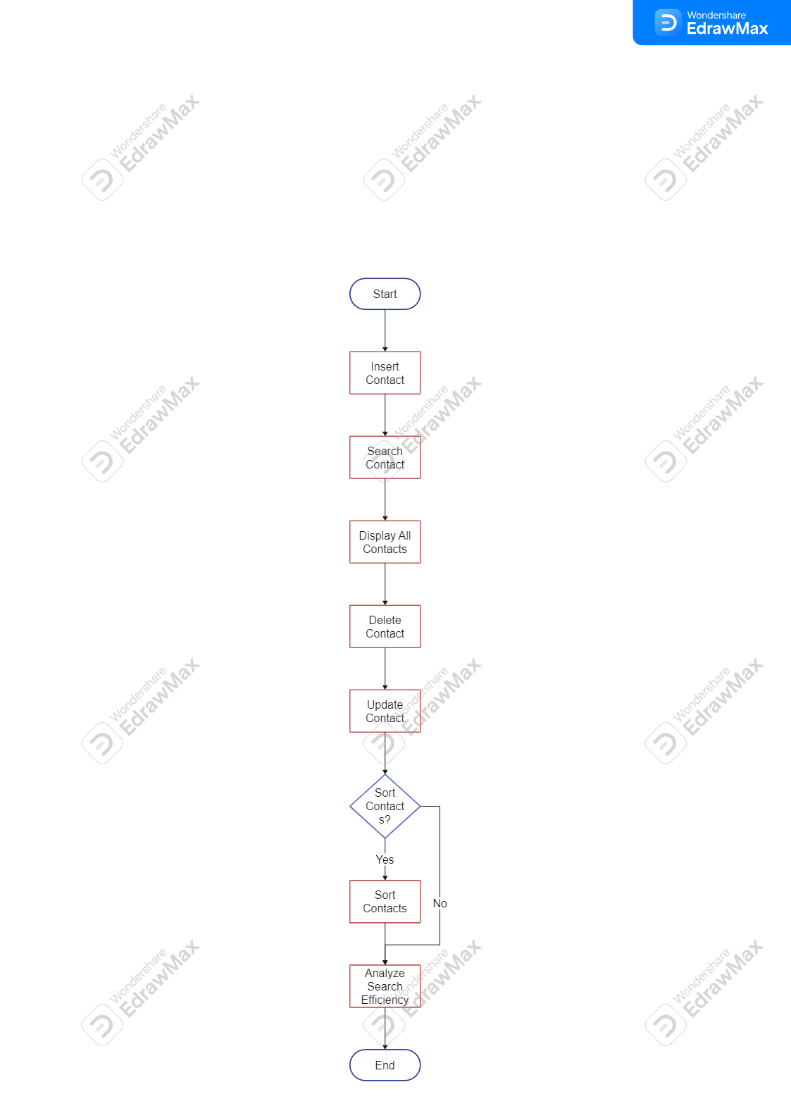

**Group members**

|  |  |
| --- | --- |
| **Student name** | **Student number** |
| Nakakoti Lucas | 224090127 |
| Hafeni N Weyulu | 224063790 |
| Shikwambi David N | 224084402 |
| Shidolo T Sarty | 224021559 |